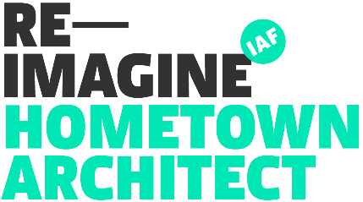
HOMETOWN ARCHITECT OPEN CALL
APPLICATION QUESTIONS GUIDE

This document is intended as a guide for your application, so that you can prepare your answers in advance. Final applications must be completed through our online form here.
Applications must be completed by the lead applicant. Applications must be completed in one sitting; progress cannot be saved. For best user experience, the form should be completed on a laptop or desktop computer, using the Google Chrome browser.

For further details on eligibility and what to include in your answers, please download the Hometown Architect Application Guidelines available here.

The deadline for applications is 16th January 2023. Late applications will not be accepted.

If you have any issues completing your application, please contact adminreimagine@architecturefoundation.ie

1. Project Location *
2. Lead applicant name *
3. Lead applicant contact number *
4. Lead applicant connection to project location *
5. Partner applicant name *
6. Partner applicant contact number *
7. Partner applicant connection to project location *
8. Tell us about your project team, and the relationship between architect and
community stakeholder. (100 words)
9. What experience does your project team have of working together on projects and initiatives? (50 words max)
10. Has your project team previously received funding from Reimagine?
Yes
No

Your Project
Tell us about your project. Who is involved? What issue is it addressing? What do you hope to achieve?
11. Project Summary. Include information on the context of the project, as well as anticipated outcomes and impact. (100 words max)
12. What groups, local authorities or communities does this project connect with? *
(50 words max)
13. What stage is the project at now? *
14. How does this project connect to the built environment, urban design or *
architecture? (50 words max)
15. How does your project contribute to the regeneration of your town centre? * Does it align with the Town Centre First policy goals of creating town centres that function as viable, vibrant and attractive locations for people to live, work and visit? (50 words max)
16. What is your proposed time line for this project? *
17. What time commitment is available from your group or organisation to help realise this project? (50 words max)
18. Is there other funding already invested in, or available for this project? *

19. Please provide an indicative budget for how the €10,000 budget would be *
spent, including breakdown of professional fees (50 words max)

Terms & Conditions
As lead applicant for this open call, please confirm your agreement with the following statements:
20. I conﬁrm that all information provided in this application form is true and correct, to the best of my knowledge, and that I am eligible to apply as outlined in the criteria provided
Yes
No
Other:
21. I conﬁrm that I am registered as a legal entity *
Yes
No
Please outline the type of legal entity in 'other' box below
Other:

22. I conﬁrm that I will be able to arrange necessary insurance for this project if
awarded funding
Yes
No
Other:
23. I conﬁrm that our project will comply with the principles set out in the Arts Council 'Paying the Artist' policy on the fair and equitable remuneration and contracting of artists.
Policy details can be found here: https://www.artscouncil.ie/about/artists-pay- policy
Yes
No
24. I agree that the Irish Architecture Foundation may retain my details for the
purposes of this application, in accordance with GDPR regulations
Yes
No
Other:

