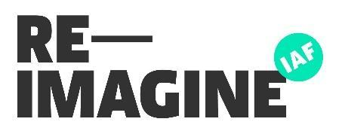
Briefing Template – Post Event Comms
Please fill this in 1 week (minimum) after your event and send to reimagine@architecturefoundation.ie
Key details
The when/what/where of the event.
Describe the outcome of the event in one sentence.
Who came to the event? What were the main things that happened?
Community engagement
How many people attended the group? Did you capture any data on why they attended, what they took away from the event?
Communications plan
Please share details of what communications your team will be doing after the event for prior approval e.g. social graphics, printed posters, press release (a press release template can be downloaded on the Brand Web hub), media interviews
Quotes
Please share a selection of key quotes captured from the event e.g. from a project team member, a community member that attended, a local politician, etc.
Checklist
Make sure you have done the following once your event ends:
- Have you uploaded any photos or other materials from the event to your shared drive?
- Have you captured a record of what happened on the day to refer back to later in the project?
- Have you considered any learnings from the event to be factored into future events?
- Were there any connections made or potential opportunities mentioned that should be followed up on?

